**NESTED CLASS**

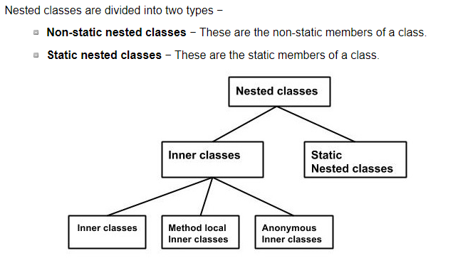

In Java, just like methods, variables of a class too can have another class as its member. Writing a class within another is allowed in Java. The class written within is called the **nested class**, and the class that holds the inner class is called the **outer class**.

Inner Class

Creating an inner class is quite simple. You just need to write a class within a class. Unlike a class, an inner class can be private and once you declare an inner class private, it cannot be accessed from an object outside the class.

class Outer_Demo {

int num;

// inner class

private class Inner_Demo {

public void print() {

System.out.println("This is an inner class");

}

}

// Accessing he inner class from the method within

void display_Inner() {

Inner_Demo inner = new Inner_Demo();

inner.print();

}

}

public class My_class {

public static void main(String args[]) {

// Instantiating the outer class

Outer_Demo outer = new Outer_Demo();

// Accessing the display_Inner() method.

outer.display_Inner();

}

}

## **Method-local Inner Class**

In Java, we can write a class within a method and this will be a local type. Like local variables, the scope of the inner class is restricted within the method.

public class Outerclass {

// instance method of the outer class

void my_Method() {

int num = 23;

// method-local inner class

class MethodInner_Demo {

public void print() {

System.out.println("This is method inner class "+num);

}

} // end of inner class

// Accessing the inner class

MethodInner_Demo inner = new MethodInner_Demo();

inner.print();

}

public static void main(String args[]) {

Outerclass outer = new Outerclass();

outer.my_Method();

}

}

## **Anonymous Inner Class**

An inner class declared without a class name is known as an **anonymous inner class**. In case of anonymous inner classes, we declare and instantiate them at the same time. Generally, they are used whenever you need to override the method of a class or an interface. The syntax of an anonymous inner class is as follows –

abstract class AnonymousInner {

public abstract void mymethod();

}

public class Outer_class {

public static void main(String args[]) {

AnonymousInner inner = new AnonymousInner() {

public void mymethod() {

System.out.println("This is an example of anonymous inner class");

}

};

inner.mymethod();

}

}

## **Static Nested Class**

A static inner class is a nested class which is a static member of the outer class. It can be accessed without instantiating the outer class, using other static members. Just like static members, a static nested class does not have access to the instance variables and methods of the outer class. The syntax of static nested class is as follows −

public class Outer {

static class Nested_Demo {

public void my_method() {

System.out.println("This is my nested class");

}

}

public static void main(String args[]) {

Outer.Nested_Demo nested = new Outer.Nested_Demo();

nested.my_method();

}

}